Data Cleaning can be done in Excel or Python

Replace NA from numeric columns to 0.

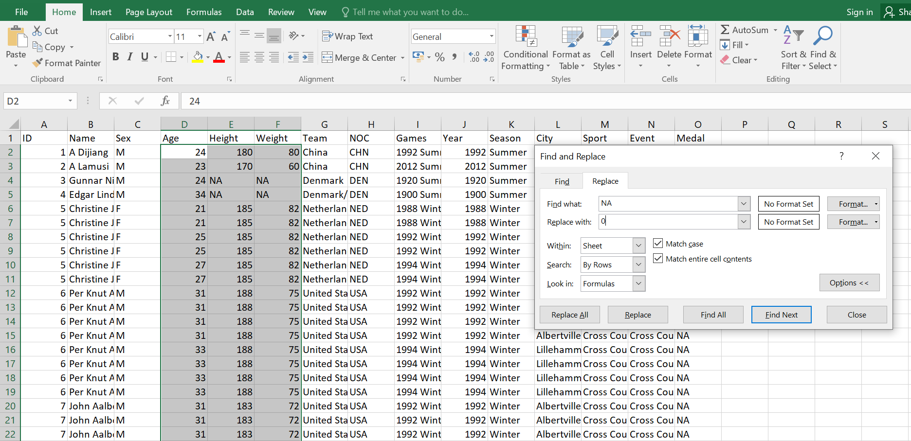

As we will be importing the dataset in csv format, commas inside entities can cause problems.

Therefore, replace commas with space.

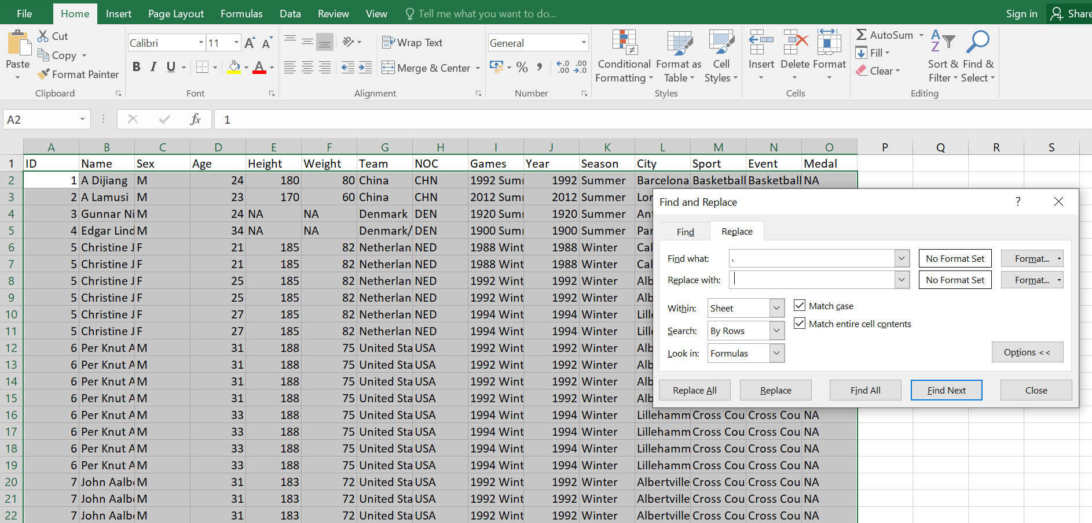

Eliminate all the duplicate values.

